Explanation for the state of the art regarding results in the folder “Results network sample_Skills_number”.

1) Identification of dependent and independent variables to work with.

Independ Variables:

- skill types (intelligence of algorithms)
- number of algorithms in the network.
- number of network (sample of networks)
- number of iterations

- Configuration of the networks
- proximity factor (the software promotes interaction with closer agents) and interaction probability.
- type of game.
- calibration of interaction (number of initial interactions so that agents create a trend to cooperate or not (1, 5, 10)).
- edge weight
- edge weight change (after cooperation or defection).
- displacement factor (to shrink or to expand the edges length after cooperation or defection).
- tolearable edge weight (9.4)
- tolerable number of defections
- initial position of edges (network configuration – spring layout)
- initial number edges (in the network).

Dependent Variables:

- clustering coefficient.
- Average path length
- degree distribution
- degree histogram
- cooperation proportion
- density
- assortativity
- modularity
- edge weight

- Statistical analysis:

1. Autocorrelation and Partial Autocorrelation Analysis

2. Seasonal Decomposition

3. Stationarity Testing and Transformation

4. Time Series Forecasting (ARIMA)

5. Granger Causality Test
- Analysis of variance (ANOVA)

2) Update of software in two ways:

2.1.- Instead of just running several iterations for one network configuration (the independent variables), I have created a sample of networks, all with the same configuration, to show variation of measurments. I have implemented the software to plot the meausrements in point 1 (except for the statistical analysis).

  - For instance: instead of running the interaction process for a network populated by 50 S++ in 20 iterations, this is an outter loop that can run this setting (20 iterations, 50 S++) multiple times and plot the variation of the measurements. The folder “sample of 20 networks - 30 iterations - 200 agents” shows some plots of a sample of 20 netowrks with 200 agents that undergo an interaction process of 30 iterations.

2.2.- In addition to this, I have created an extra outter loop that runs, not just one configuration, but multiple. Then, I plot the proportion of cooperation (how the proportion of cooperation changes with several given combinations of number of algorithms involved and their intelligence). For it:

  - I have created a list with all the algorithms in Crandall’s study and have given them a rank of intelligence. This was done in Crandall’s study, making a classification regarding algorithm’s skills and performing (level of intelligence). This shows the variability in intelligence -skills- of the algorithms.
  - I have created a list of different number of agents (group size) that each network should have
  - and I have run the interaction process for all the possible combinations. As an example, I can run this multiple combination setting:
algorithm types: S++, manipulator-bully, manipulator-gf, S++-simp, S, fp, br1, eeew.
number of agents for each type: 200, 180, 160, 140, 120, 100, 80, 60, 40.
sample of networks: 20 networks
interaction process: 40 iterations.

So, while running all the combinations we start by a sample of 20 networks of 200 S++ agents in an interaction process of 40 iterations, and measures proportion of cooperations and possible tipping points in the changes of cooperation throughout the 40 iterations. Then the software creates a sample of 20 networks of 180 S++ agents wit 40 interactions, and measures. Then, 20 networks of 160 S++ agents (40 iterations). Then 20 -140 – S++ - 40. Etc.

After S++ is finished we run all the these combinations for the folowing type of agent: manipulator-bully, manipulator-gf, S++-simp, S, fp, br1, and eeew.
After all, we plot the results that can be seen in “proportion of cooperation.png” in the folder “Skill_Number-cooperation”.

3) Text File collecting all the measurements:

I have created a text file that collects all this data: for each combination of algorithm type/number of agents in the network/ number of networks in the sample of networks it collects the measurements of point (1).

- This allows a) to work with the data without having to run all the process every time (because the whole process is very time consumming), and b) to carry out statistical analysis of the times series (how measurements change throughout the iterations and different combinations of skills and number of agents).

Leveraging this csv file we have carried out some analyses.

3.a. Plot of cooperation proportion with prospective tipping points.

We have first divided the sample into four groups, due to two factors: number of agents in the sample, and skill type. We simplified both factors grouping the sample into:

- large and smaller size:
The range of number of agents may not be the optimal. We used [200,180,160,140,120,100,80,60,40]. Idealy the range should be larger, including thousands of agents. We divided this group into two clusters:
- Larger group (>100 agents): 200,180,160,140,120
- Smaller group (<= 100 agents): 100,80,60,40

- high and low intelligence:
- 'S++', 'manipulator-bully', "manipulator-gf" constitute the smarter (more skillful types),
- the rest ("S++_simp", "S", "fp","br1") account for less intelligent algorithms.

This classification has a handicap. The seven type of algorithms employed are actually the seven most intelligent in the ranking used by Crandall for classifying the 25 algorithms he tested in his study (Crandall et al., 2018). It should be more itneresting to confront some of these most intelligent algorithms against those at the bottom of the ranking.

Cooperation proportion:
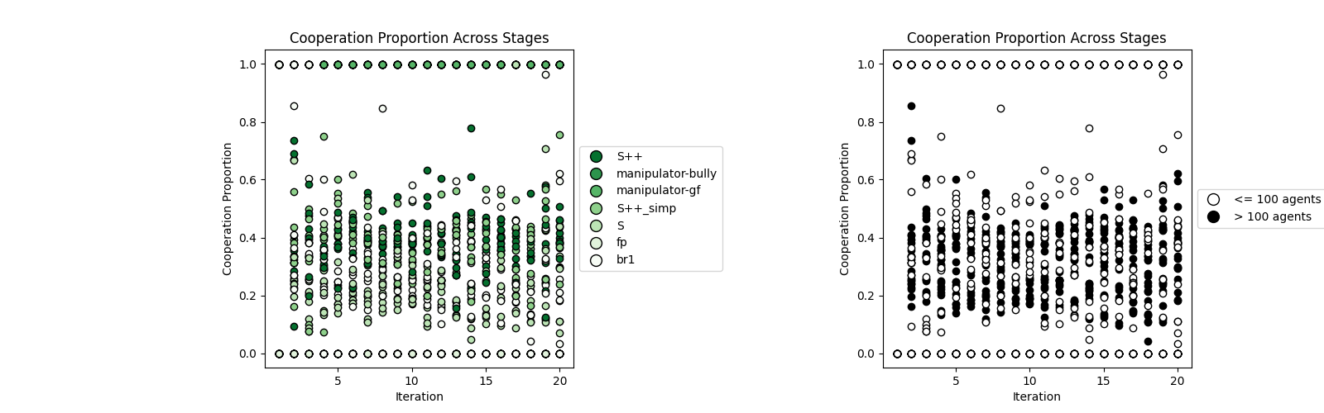

Prospective tipping points:
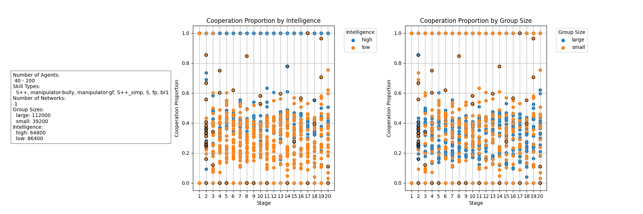

3.a.1. Analysis of variance

ANOVA is carried to test the influence of the two factors (skills and number of agents) and their interaction on the null hypethsis. The latter means the factos have no effect on the values of coopeartion, and the corresponding groups have no significant differences: they’re the same. However, the results show that:
sum_sq df F PR(>F) partial_eta_squared
C(intelligence) 102.270822 1.0 1587.386674 4.317140e-225 0.558273
C(group_size) 0.008983 1.0 0.139426 7.089151e-01 0.000111
C(intelligence):C(group_size) 0.002365 1.0 0.036714 8.480796e-01 0.000029
Residual 80.920518 1256.0 NaN NaN NaN

P-values (PR(>F))
- C(intelligence): The p-value is extremely low (4.317140×10−225), which indicates a significant effect. The null hypothesis (no effect of intelligence on cooperation proportion) can be rejected with 95% confidence.
- C(group_size): The p-value is 0.7089 is not statistically significant. The null hypothesis (no effect of group size on cooperation proportion) cannot be rejected.
- C(intelligence)
- (group_size): The p-value is 0.8481 is also not statistically significant. The null hypothesis (no interaction effect between intelligence and group size on cooperation proportion) cannot be rejected.

Effect Sizes (Partial Eta Squared)
- C(intelligence): The partial eta squared is 0.558 indicates a large effect size. Intelligence accounts for a substantial proportion of the variance in cooperation proportion.
- C(group_size): The partial eta squared is 0.000111 indicates a very small effect size. Group size accounts for a negligible proportion of the variance in cooperation proportion.
- C(intelligence)
(group_size): The partial eta squared is 0.000029 indicates a very small effect size. The interaction between intelligence and group size accounts for a negligible proportion of the variance in cooperation proportion.

Potential for Significance with Increased Sample Size
C(group_size) and C(intelligence)
(group_size) have p-values close to typical significance thresholds (0.05), which may suggest that with an increased sample size, these effects may become significant. If the sample size is increased, the statistical power of the test increases (Power analysis). Higher power means higher probability of detecting a true effect, if it exists. The current p-values (0.7089 and 0.8481) suggest that there might be a trend, but the sample size might be small to detect a significant effect.
However, size considerations point otherwise. Despite the potential for significance, the effect sizes for C(group_size) and C(intelligence) x (group_size) are extremely small. Even if these effects become statistically significant with a larger sample size, they may not be significant. The small partial eta squared values indicate that these factors explain very little of the variance of the cooperation proportion.

Conclusion
- Intelligence has a highly significant and large effect on cooperation proportion. Group size and its interaction with intelligence do not have significant effects and their effect sizes are very small.
- Future Prospects: Increasing the sample size might lead to statistical significance for group size and its interaction with intelligence, but their practical significance is likely to remain low due to the very small effect sizes. Therefore, even if p-values drop below 0.05 with more data, the effect sizes suggest that these factors do not substantially influence cooperation proportion.

3.a.2. Time Series (Autocorrelation tests)

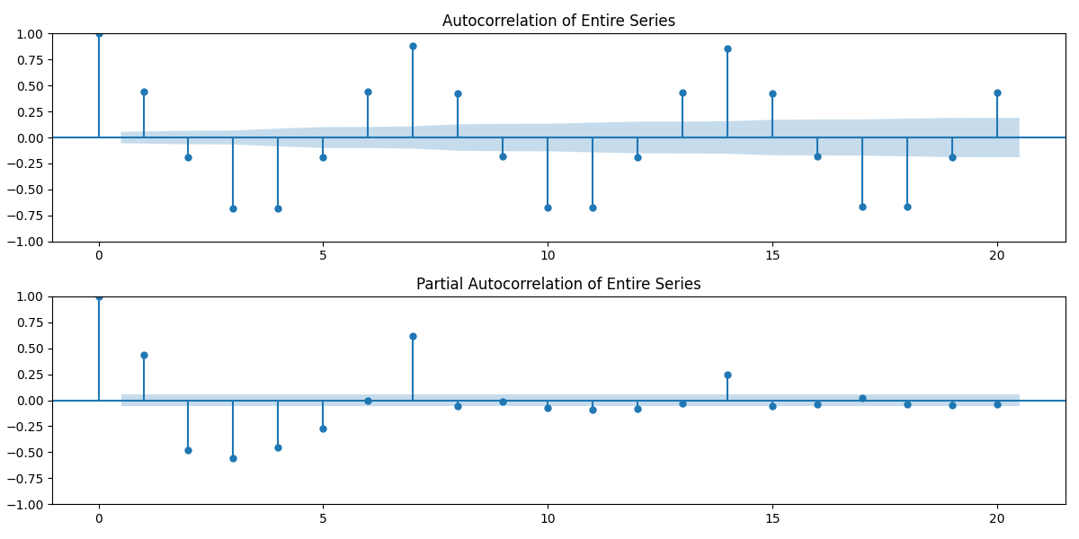

Autocorrelation (ACF)
Measures the correlation of a time series with its own past values.
The graph shows significant positive lag at the beginning indicates strong correlation with immediate past values. Subsequent lags show fluctuations, indicating varying levels of dependence over time.
Partial Autocorrelation (PACF)
Measures the correlation of a time series with its own past values, accounting for the values of the intermediate lags. The first lag shows significant positive correlation. Subsequent lags show diminished correlations, indicating that the effect of past values is largely captured by the first few lags.
Context of Cooperation Proportion:
- ACF and PACF plots help understand how past cooperation levels influence future cooperation.
- Significant Initial Lags: Suggest that recent cooperation levels have a strong influence on immediate future cooperation.
- Diminished Longer Lags: Indicate that while immediate past cooperation is influential, the effect diminishes over time.
ACF: Shows that recent cooperation levels (up to a few time steps ago) significantly influence current cooperation. The periodic behavior indicates regular cycles in how smart agents cooperate.
PACF: Indicates that direct influence from specific past cooperation levels diminishes as we go further back, with the most significant impacts coming from recent past levels.
In one word: Partial autocorrelation shows that direct influences from past cooperation decrease over time, with the most significant impacts coming from recent interactions.

3.b. Measurements

3.b.1. Average path length:
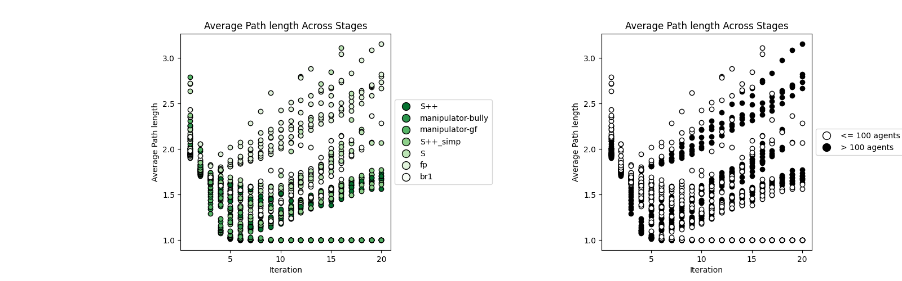

1) decreases for smarter agents, going from 2.5 to 1 and then stabilizing around 1.5 with a clear decrease in the variance of average path length (smarters' apl converges to a less variable range), wheras less intelligent agents a) increse varibility and the value of apl.

2) when it comes to group sizr, apl starts decreasing and then increasing for larger and smaller sizs, but for larger sizes apl grows bigger

Smarter Agents: The initial decrease in APL followed by stabilization indicates that smarter agents optimize their network connections, resulting in shorter paths and a more efficient network structure. The reduction in variability further implies that this optimized structure is consistent and stable across the network.
Less Intelligent Agents: The increase in both APL and its variability indicates that less intelligent agents' networks become less efficient and more erratic over time. Longer paths and increased variability suggest a lack of optimization in their network connections.
Interpretation:
- Smarter agents are able to form more efficient networks with shorter paths between nodes, which stabilize over time.
- Less intelligent agents struggle to maintain short paths, leading to longer and more variable APLs.

Smaller Groups: The initial decrease in APL indicates an initial phase of improved connectivity and efficiency. However, the subsequent increase suggests that this improvement is not sustained, leading to a less efficient network over time.

Larger Groups: The larger increase in APL for larger groups indicates that they face more significant challenges in maintaining efficient connectivity. The network structure in larger groups becomes more inefficient compared to smaller groups, likely due to the complexity and increased number of connections required.

3.b.2. Clustering coefficient:

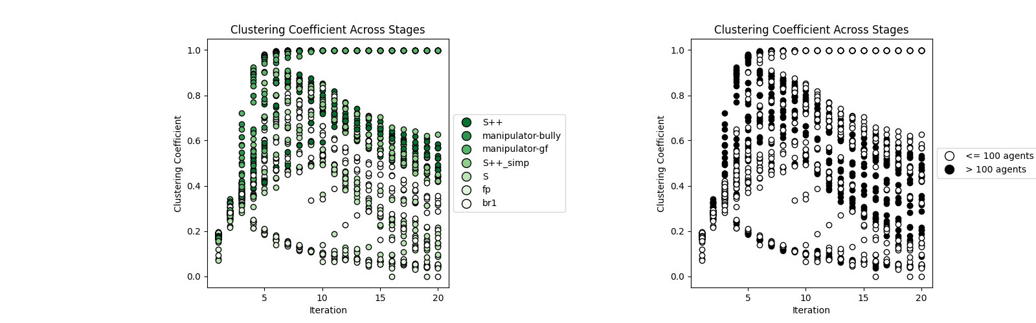

Trend - skills: Clustering coefficient tends to decrease over iterations for all intelligence levels, but smarters have higher.
- Smartest Agents (S++): Start with a high clustering coefficient (~0.9), which declines and stabilizes around 0.4-0.5.
- Less Intelligent Agents: Have lower initial clustering coefficients that decline more sharply and fluctuate more.
- Variance: Higher intelligence agents show less variance in their clustering coefficients compared to less intelligent agents.
Interpretation:
- Higher intelligence agents maintain more clustered networks initially, which indicates strong local connections.
- Over time, these networks become less clustered, possibly due to diversification of connections.
- Less intelligent agents start with less clustered networks and experience higher fluctuations, suggesting unstable local network structures.
Trend - size: Clustering coefficient generally decreases over iterations for both group size.
- Group Size Comparison:
  - Larger groups show higher initial clustering coefficients (~0.8) that decrease and stabilize around 0.3-0.4, and lower variance.
  - Smaller Groups: Start with low values, and then increase and descend with wider variation (fluctuations).
Interpretation:
- Larger groups initially have more clustered networks, which could facilitate cooperation.
- As iterations progress, the decrease in clustering might indicate an attempt to form more efficient networks.
- Larger groups show less variability, despite the complexity of managing more connections.

3.b.3. Density:
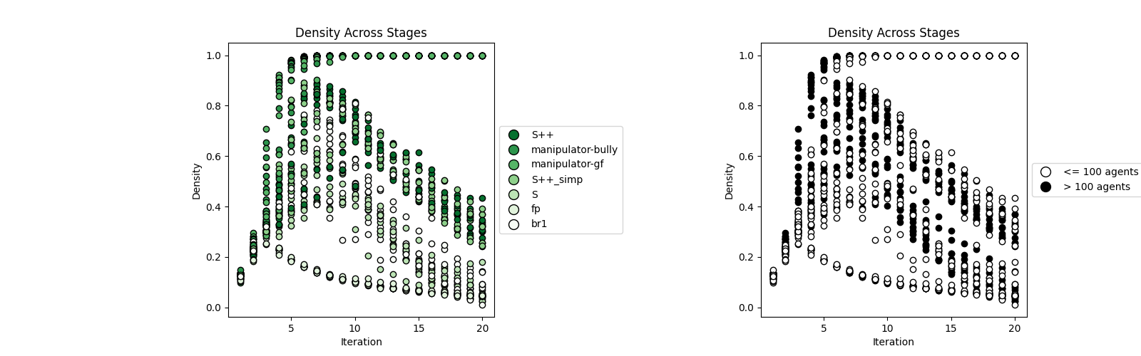

Left Plot (Skill Types and Intelligence Levels) --> Less intelligence, less density generated

- S++ (Smartest and most skillful agents) have a wide range of densities from low to high throughout the iterations.
- As intelligence and skill decrease (moving down the legend), there is a trend of decreasing density across the iterations.
- Density decreases more uniformly across stages for less intelligent agents, indicating that higher intelligence allows for more variability in network density.

Right Plot (Group Sizes)
- Larger group sizes exhibit a wider range of densities compared to smaller group sizes (which seems to follow through obvious).
- Both group sizes start with a higher density, which decreases over iterations but larger groups maintain a more varied density.
3.b.4. Assortativity:

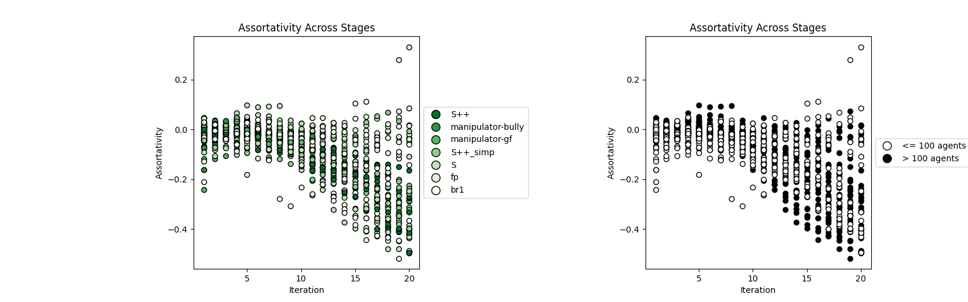

Left Plot (Skill Types and Intelligence Levels)

Assortativity tends to be negative
- Variance of Assortativity grows with time
- The smartest agents (S++) have a higher assortativity initially, which fluctuates and eventually becomes more negative, whereas less intelligent agents stabilize around 0..
- As we move down the legend, the assortativity remains more negative and stable across iterations for less intelligent agents.
- Higher intelligence agents seem to have higher positive assortativity, indicating a tendency to connect with similar nodes.

Right Plot (Group Sizes)
- Larger group sizes show more fluctuation in assortativity compared to smaller group sizes.
- Both groups exhibit similar trends, starting around zero and remaining relatively stable with negative assortativity across iterations.
- The interaction between nodes in smaller groups seems to have more variability.

This interpretation suggests that smarter agents develop a clearer preference for connecting with dissimilar nodes over time, while less intelligent agents consistently connect with dissimilar nodes but with more fluctuation in their connectivity patterns.

3.b.5. Modularity:

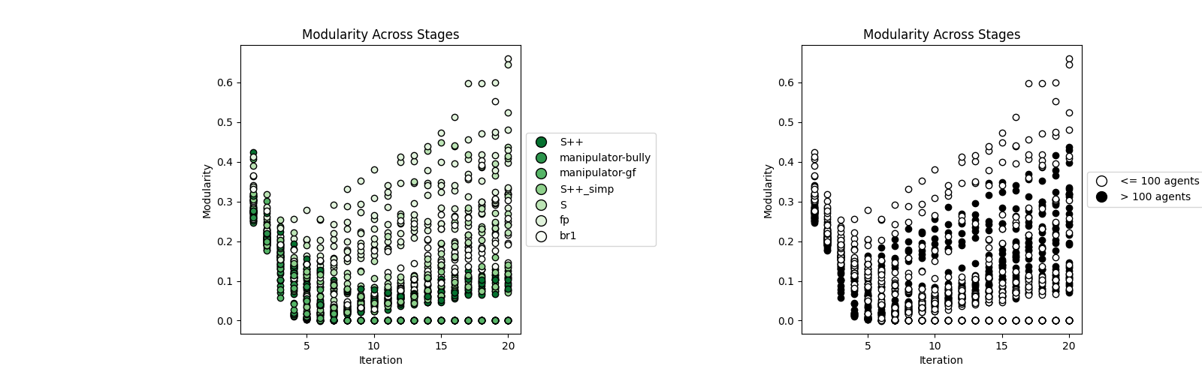

Left Plot (Skill Types and Intelligence Levels)
- S++ agents start with lower variability of modularity and it increases over iterations, showing the formation of more defined communities.
- Less intelligent agents (moving down the legend) show a higher and wider varied modularity.
- Higher intelligence allows for more significant community structure development over time.

Right Plot (Group Sizes)
- Larger groups show higher modularity over iterations, indicating more pronounced community structures compared to smaller groups.
- Both larger and smaller groups exhibit an increase in modularity over time, but the increase is more pronounced in larger groups.

Overall, these metrics suggest that smarter agents form more efficient, clustered networks that support sustained cooperation, while less intelligent agents and larger groups face challenges in maintaining efficient, cooperative networks.

